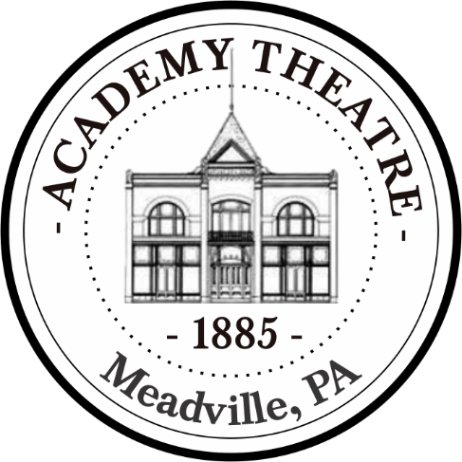
Fact Sheet

- Ernest Hempstead commissioned the building of the Academy Theatre in 1885.
- Local legend claims that Ernest still haunts the building!
- J.M. Wood, the architect of the building, said that he wanted to build Meadville “a Temple of Amusement”.

- In 1901, Lillian Mortimer’s “No Mother to Guide Her” took the stage at The Academy Theatre and was a smash hit. One hundred and twenty-five years later, the play had a revival at the Academy.

- The theatre originally had 600 seats. Following the renovation in the early 1990s, the theatre now houses 470 seats.

- The theatre has had over 315 plays and 100 touring groups take the stage in its storied 133-year history.

- The Academy Theatre houses two performance spaces: The Main Stage and The Academy Gallery.

- Productions at The Academy Theatre are all produced by a dedicated volunteer base, who spend countless hours rehearsing, designing, and building every aspect of every show.

- The Academy hosts more than 12,000 patrons each season and nearly 1,000 young people participate in educational programs and youth productions.

- Each season at the Academy Theatre runs from October to June and includes five performances on the mainstage as well as several limited engagements shows.

- The 2018-2019 season will be the 133rd anniversary of The Academy Theatre.

